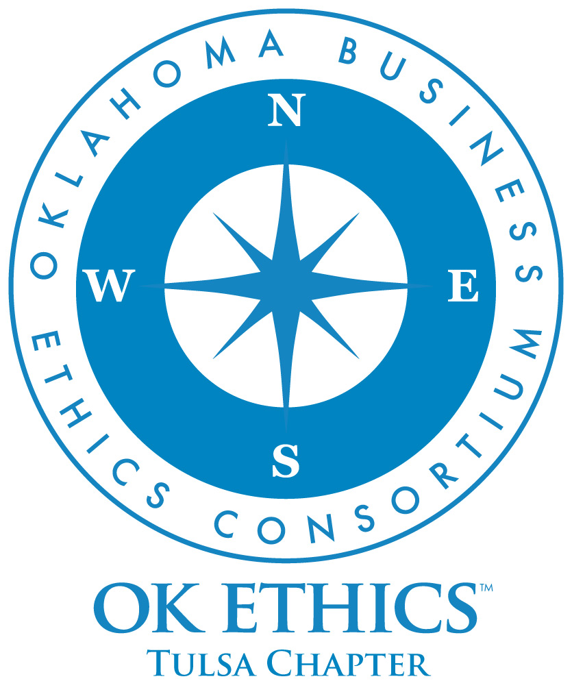

OKLAHOMA BUSINESS
ETHICS CONSORTIUM
Tulsa Chapter 5th Anniversary Event
May 12th, 2009

Meeting Agenda

Program: 6:15 – 7:00

I. Welcome Nick Minden, Chapter President
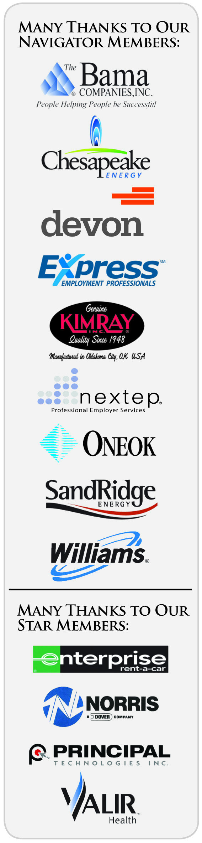

II. Opening Comments Kell Kelly, CEO SpiritBank

III. Honoring our Volunteers Nick Minden, Chapter President

IV. Honoring our Members Lynn Flinn, Chapter Founder

V. Reporting the OKEthics Story Royce Kelly, Legacy Team Member

VI. Message from our Founder Shannon Warren

VII. Closing remarks Nick Minden, Chapter President

Many thanks to our volunteers and Legacy team members for making this and every other meeting possible: Carol Swarthout, Lynn Flinn, John Stancavage, Michael Oonk, Whitney Mathews, Jan Laub, Jenny Lizama, Jennifer Lyon, Tom Clatfelter, David White, Shere Rockwell, Kevin Kennemer, Jana Momeni, Kari Culp, Royce Kelly. In addition, special thanks to Deborah Gavula, OKEthics Administrative Assistant.

General Disclaimer: Members of the Oklahoma Business Ethics Consortium frequently share information concerning various issues and developments that may have legal implications. The discussions, commentary, and handouts at Consortium meetings or presentations to other organizations are for general informational purposes only. They cover only some aspects of the subject topic, and do not constitute a complete legal analysis of the topic or how it might apply to any particular set of facts. Before taking any action based on information presented during a Consortium event, participants are encouraged to consult a qualified attorney.
The observations and comments of presenters at Consortium meetings and networking are the views and opinions of the presenter and do not constitute the opinion or policies of the Consortium or any of its members. Presenters are respectfully requested to avoid profanity, preaching, politics and self-promotion during their lectures.

